**DNS Amplification Attack**

1. Here we can see the different attackers and defenders connected to the internet via a switch and an external router.

1. Now we open the attacker's PC and run a basic script of dnsdrdos to help us in the attack.

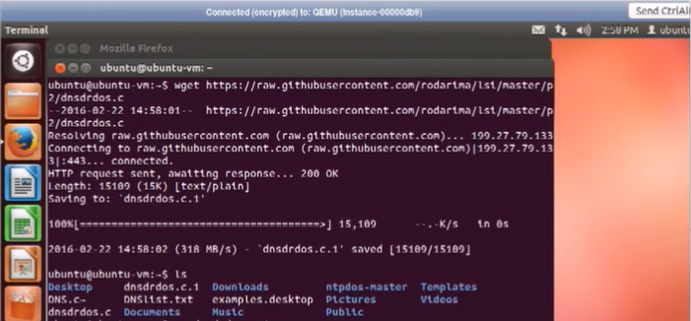

1. Now we need to compile the file using gcc compiler.

1. Copy a list of free DNS addresses in a text file.

1. Here, we run the dnsdrdos file wit the dnslist, the target IP, and the number of packets sent. So now the attack has started.



1. Now on the victim PC, we run wireshark and we can see that the number of packets is rising rapidly.

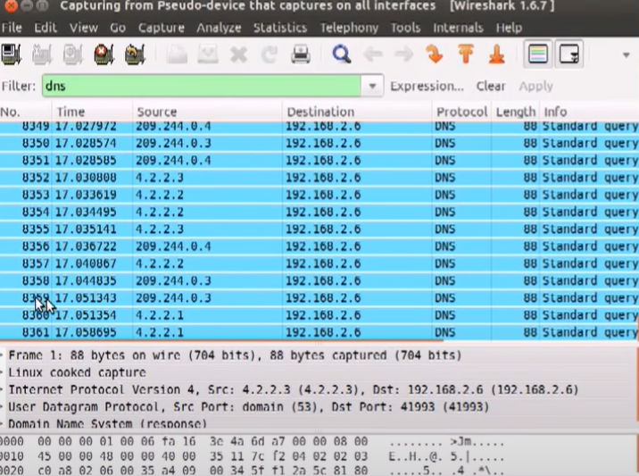

1. Normally the download speed is around 35 MB/sec but due to DNS amplification attack the speed has been reduced to 25 MB/sec.

